**PESTEL Analysis**

PESTEL analysis is a well-known framework or tool to analyze the market before the launch of any project or product into the market. This tool is especially useful when starting a new business or entering a foreign market. Prior to launching product in the public, it is essential for us to identify the factors that are likely to have an impact on the value and mechanism of our project. PESTEL stands for:

P – Political

E – Economic

S – Social

T – Technological

E – Environmental

L – Legal

**Why PESTEL analysis is important?**

Whether it is a newly established company or an established organization, PESTEL can help every business owner in identifying significant changes in the political, economic, social, technological, environmental and legal factors. It helps in better strategic planning.

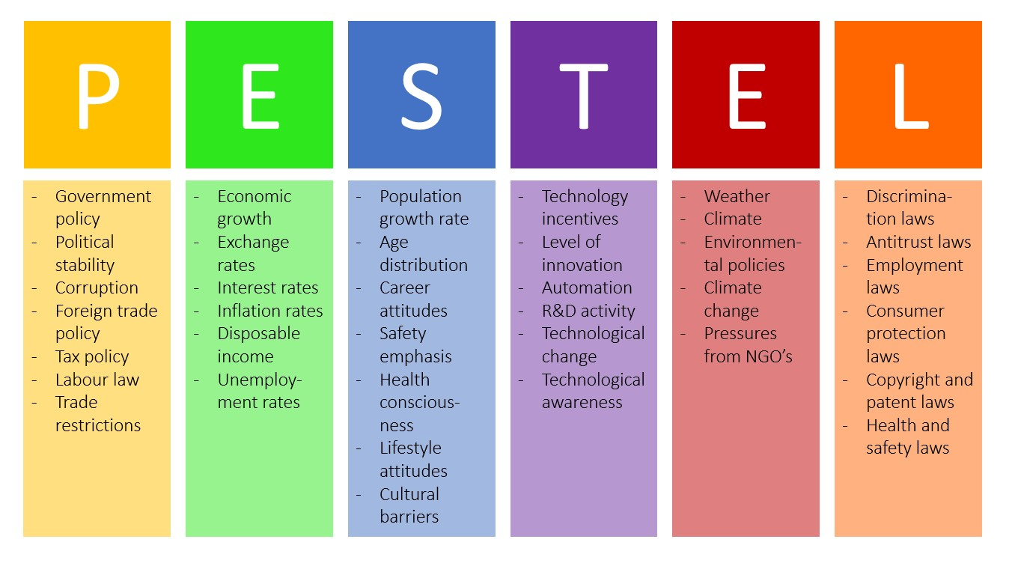

**Political:** This includes factors like political stability, tax guidelines, trade regulations, safety regulations and employment laws.

**Economic:** Inflation rates, interest rates, economic growth, unemployment rates, exchange rates etc.

**Social:** Demographic characteristics, custom and values of population. The population trends like age distribution, income distribution, growth rate etc.

**Technological:** These factors affect the operations of the technology industry and market favorably or unfavorably.

**Environmental:** It includes ecological and ecological traits such as climate, weather, environment offsets etc.

**Legal:** It includes labour laws, discrimination laws, consumer protection laws, copyright, patent laws etc. It shows that companies must know what is legal and illegal to make trade successful without compromising ethics and principles.